Threads
A thread is a basic unit of CPU utilization; it comprises a thread ID, a program counter, a register set, and a stack. It shares with other threads belonging to the same process its code section, data section, and other operating-system resources, such as open files and signals.
An application typically is implemented as a separate process with several threads of control.
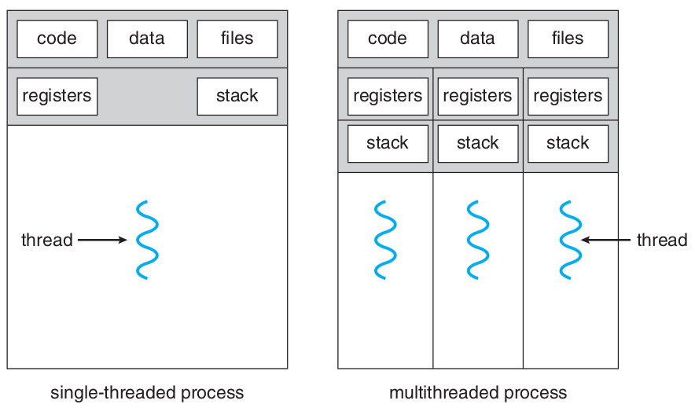

In certain situations, a single application may be required to perform several similar tasks. If the web server ran as a traditional single-threaded process, it would be able to service only one client at a time, and a client might have to wait a very long time for its request to be serviced. When the server receives a request, it creates a separate process to service that request.

Threads also play a vital role in remote procedure call (RPC) systems. RPCs allow interprocess communication by providing a communication mechanism similar to ordinary function or procedure calls.

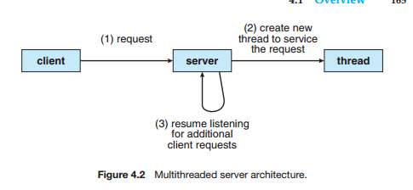

Most operating-system kernels are now multithreaded. Several threads operate in the kernel, and each thread performs a specific task, such as managing devices, managing memory, or interrupt handling

Benefits
- Responsiveness: allow a program to continue running even if part of it is blocked or is
performing a lengthy operation, thereby increasing responsiveness to the user.
- Resource sharing: Processes can only share resources through techniques such as shared memory and message passing. Threads share the memory and the resources of the process to which they belong by default. The benefit is that it allows an application to have several different threads of activity within the same address space.
- Economy: Because threads share the resources of the process to which they belong, it is more economical to create and context-switch threads
- Scalability: can be even greater in a multiprocessor architecture, where threads may be running in parallel on different processing cores

Multicore Programming
Whether the cores appear across CPU chips or within CPU chips, we call these systems multicore or multiprocessor systems. Multithreaded programming provides a mechanism for more efficient use
of these multiple computing cores and improved concurrency

On a system with a single computing core, concurrency merely means that the execution of the threads will be interleaved over time (Figure 4.3), because the processing core is capable of executing only one thread at a time. On a system with multiple cores, however, concurrency means that the threads can run in parallel, because the system can assign a separate thread to each core (Figure 4.4).
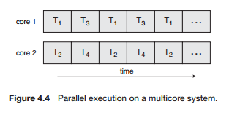

Notice the distinction between parallelism and concurrency in this discussion. A system is parallel if it can perform more than one task simultaneously. In contrast, a concurrent system supports more than one task by allowing all the tasks to make progress.

